Experiment 10
To execute the following commands in Kali Linux Operating Systems:
Free command
Sort command
History command
Aim: To execute and study the free, sort, and history commands in Kali Linux Operating System and observe their outputs.
i) free Command
Command:
free -h
cat fruits.txt
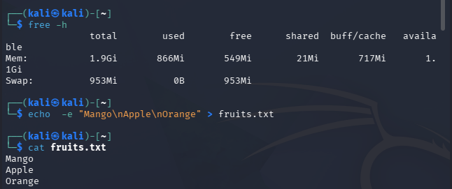
Explanation: The free command displays the memory usage of your computer, including RAM and swap memory.
RAM is the temporary memory your computer uses while programs are running.

ii) sort Command
Command:
sort fruits.txt
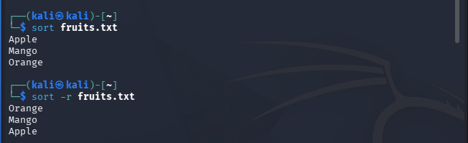
Explanation: The sort command arranges lines of text in order, usually alphabetically.
Sample output:
Apple, Banana, Mango, Orange
sort fruits.txt
Apple, Banana, Mango, Orange
iii) history Command
Command:
history
cat fruits.txt
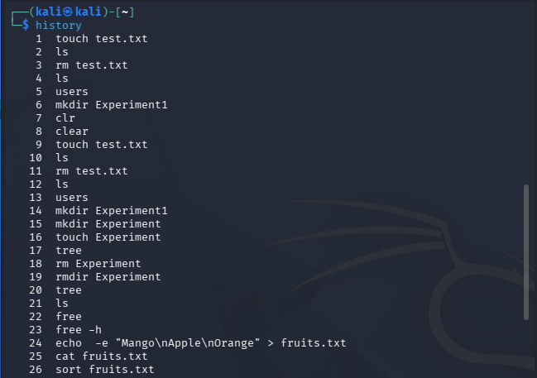
Explanation: The history command displays commands you previously entered in the shell.
Orange
Mango
Banana
Apple
Sorted output:
Command: sort fruits.txt
Original output: Mango, Apple, Banana, Orange
cat fruits.txt
echo -e "Mango\nApple\nBanana\nOrange" > fruits.txt
Sort command setup:
Result: Thus, the free, sort, and history commands were successfully executed in Kali Linux, and their outputs were displayed and verified.

